YAKIT SENSÖRÜ

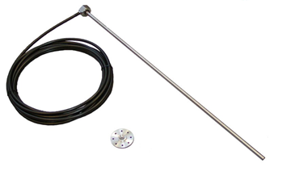 | 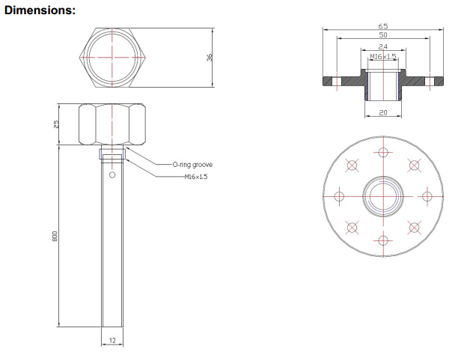

Technical specification:
Measuring principle: | capacitive
Measuring range: | 0 – 180 … 1000 mm, cuttable to size
Operating medium: | Fuel quality diesel oil
Output signal: | Exclusive data protocol
Measurement precision: | ~98% (this accuracy is guaranteed only at full refueling!)
Supply voltage: | +9V … +36V DC
Current consumption: | < 3 mA
Cables: | 7m, 3×0,14, in cable protective tube
Storing and operating temperature range: | -20 C° ... +60 C°
Protection: | IP68
Material: | Stainless steel
Dimensions: | LT36 × 25 hexagonal casing connecting thread: M16 × 1,5 probe: Ø 12 × 180 … 1000
Gross weight: | 1000g (packed)

